Taco12 Build Guide

Designed by PsychicTaco13

Available [here](https://tacokb.com/) <https://tacokb.com/>

Discord <https://discord.com/invite/QKPhDEH9gE>

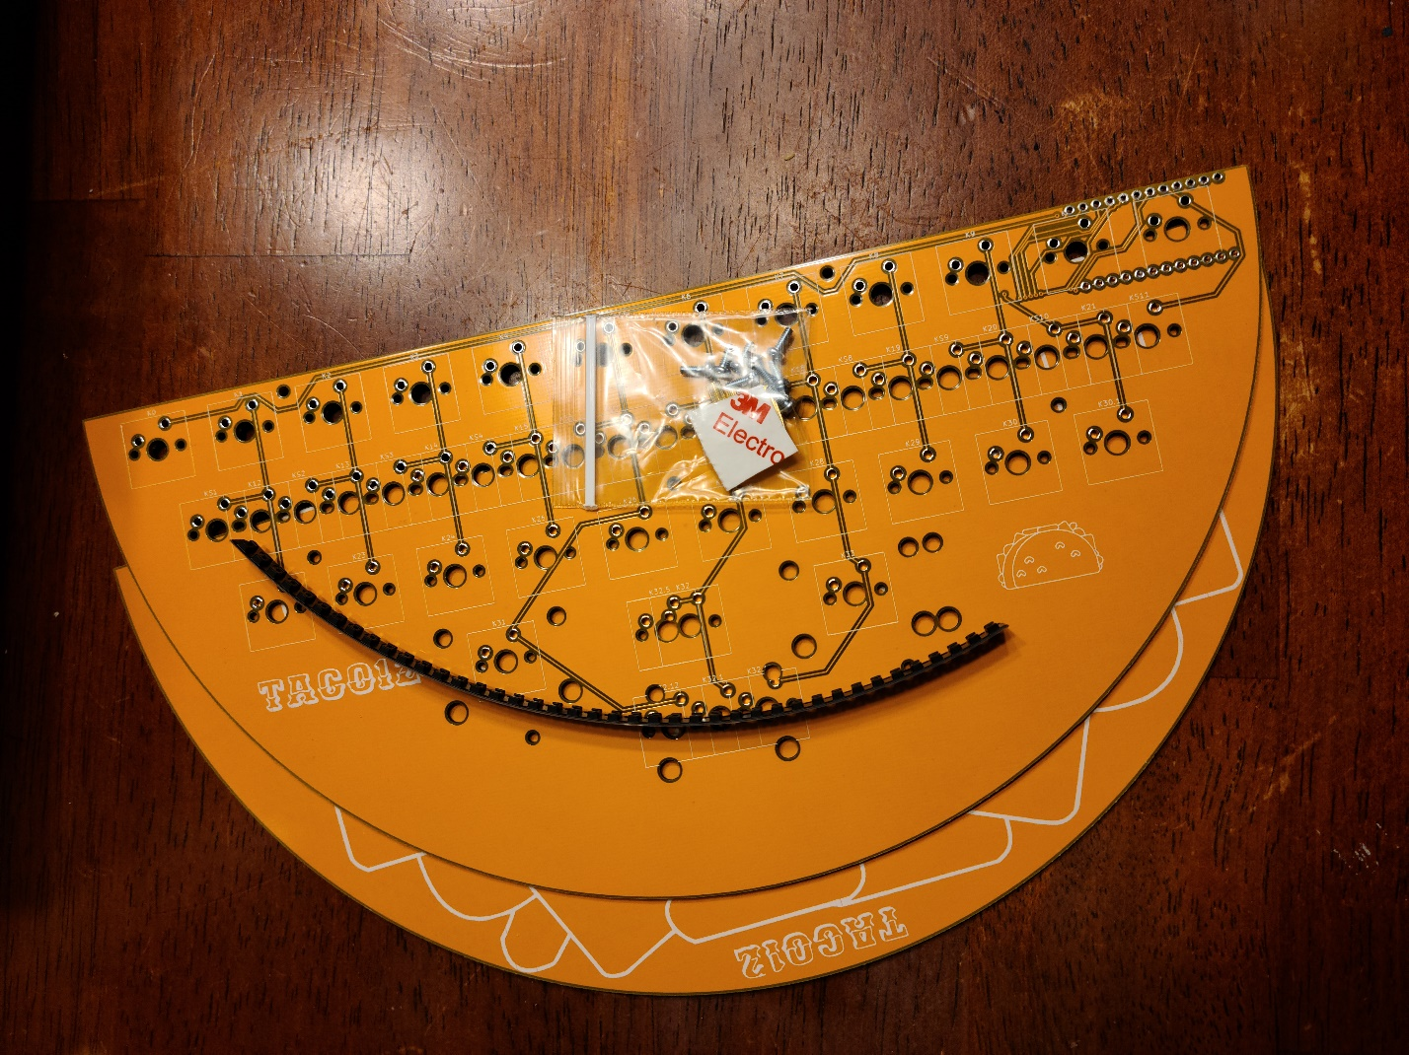

All of these will be included in every DIY Kit

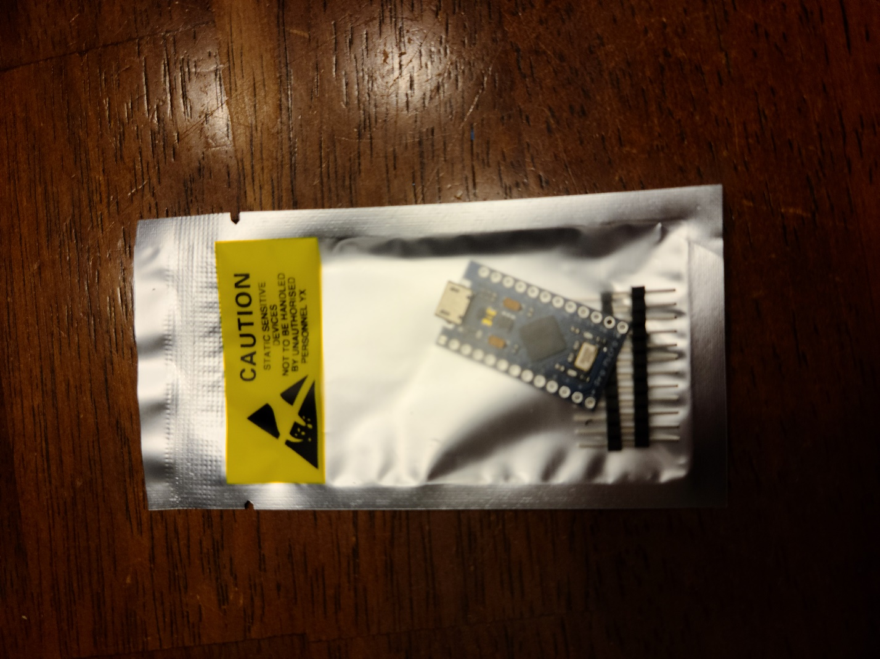

If you ordered a pro micro, this will be included otherwise you need one or something pro micro compatible (elite-c,bit-c,proton-c) Pro micros are available at [tacokb.com](https://tacokb.com/) if you find yourself still needing one.

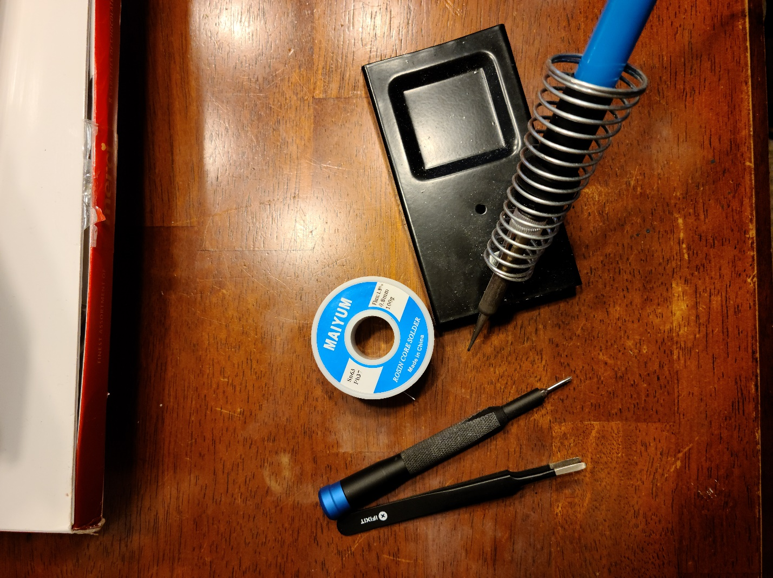

The tools you need will include

* Soldering Iron
* Solder
* Tweezers
* A Philips screwdriver(magnetic will help)

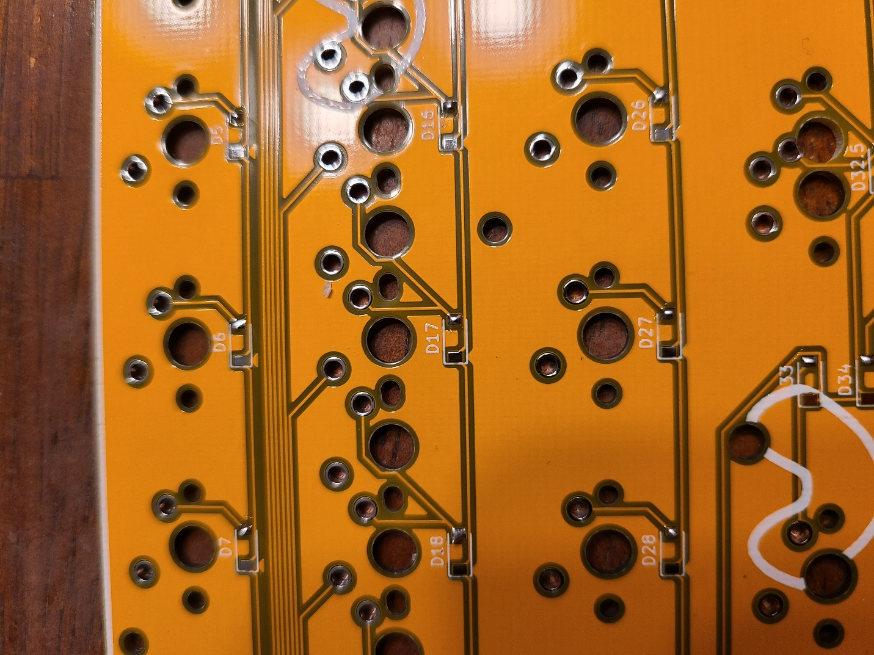

You will want to start with your diodes. Depending on what hand you use your soldering iron with, you will want to put a little bit of solder on each pad on that side. For this example, I put the solder the right pad of each diode footprint.

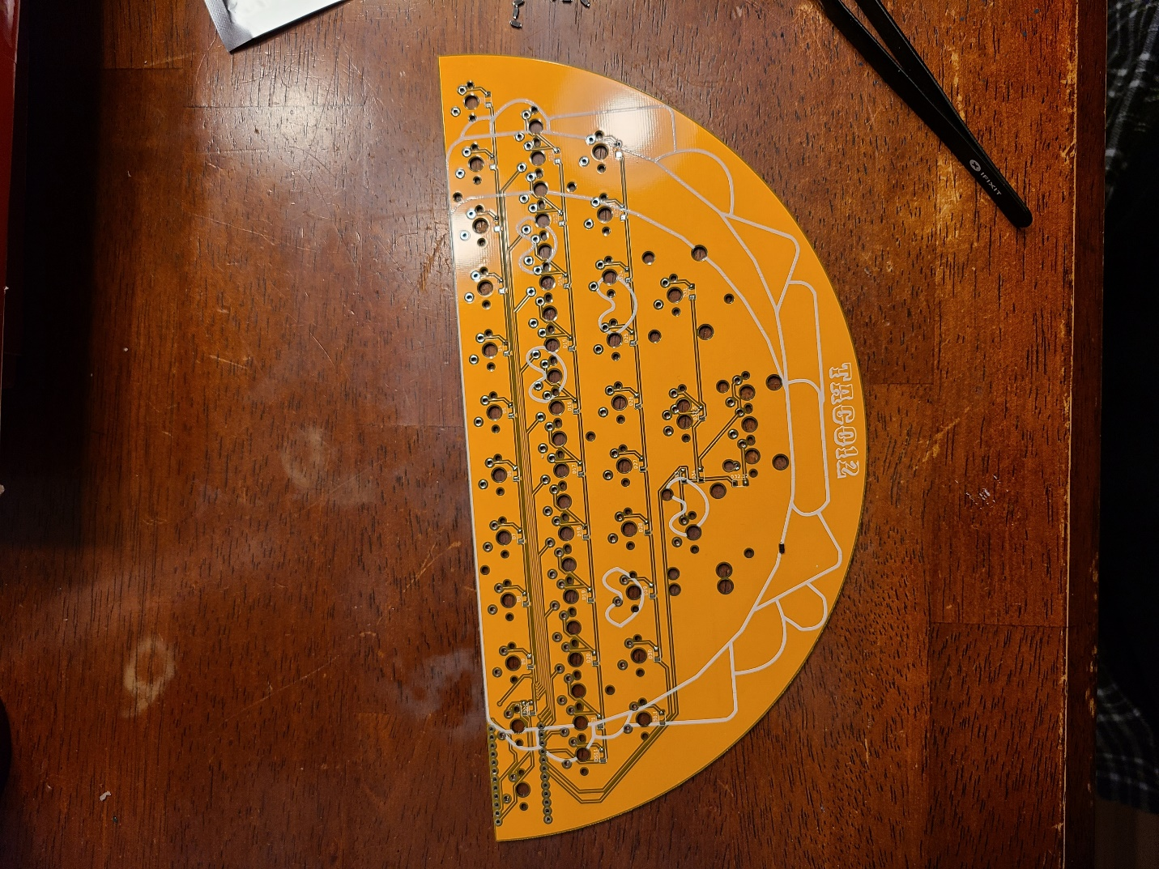  
Next you will want to grab your tweezers and diodes.

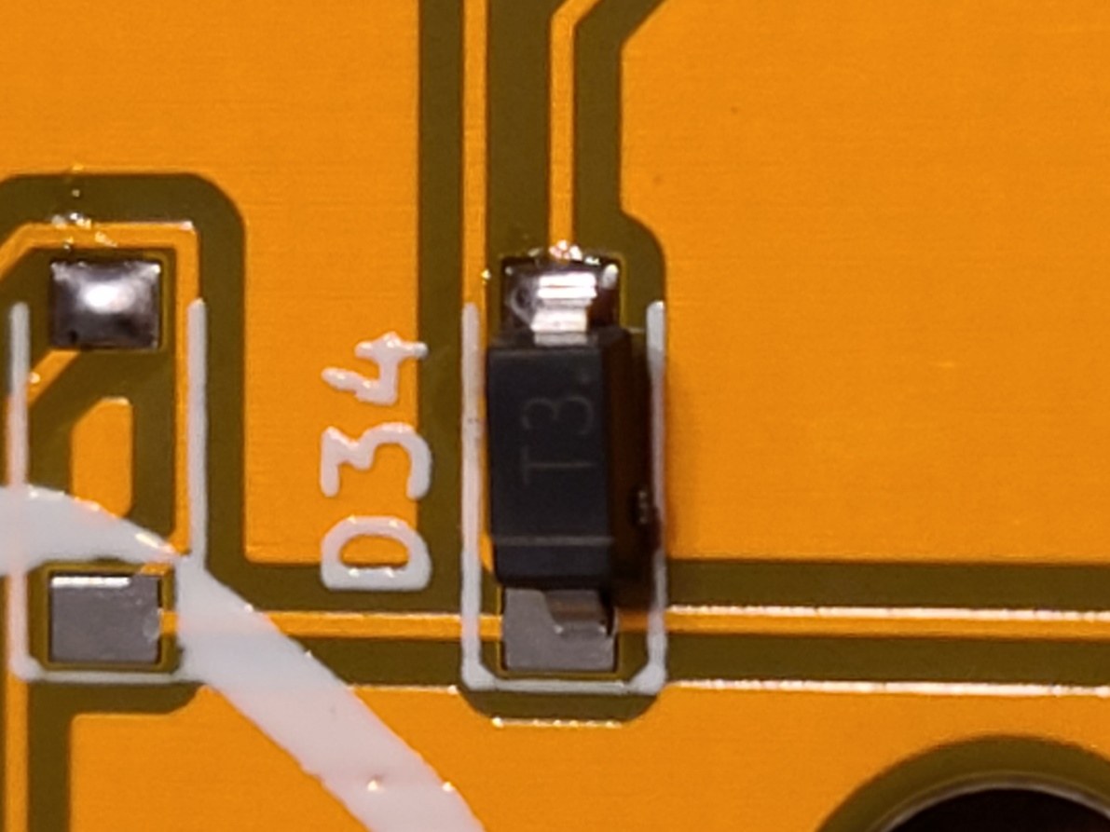

You will want to orient your diode with the line facing to the left of the PCB if you are following the orientation I used above. You will heat the pad you put the solder on and place the diode with your tweezers into the above position (as straight as possible, as you can see, I’m not perfect either!). Here is a video clearly demonstrating what you need to do. [[https://www.youtube.com/watch?v=Jpj3tilIaik&t](https://www.youtube.com/watch?v=Jpj3tilIaik&t=99s)](https://youtu.be/Jpj3tilIaik)

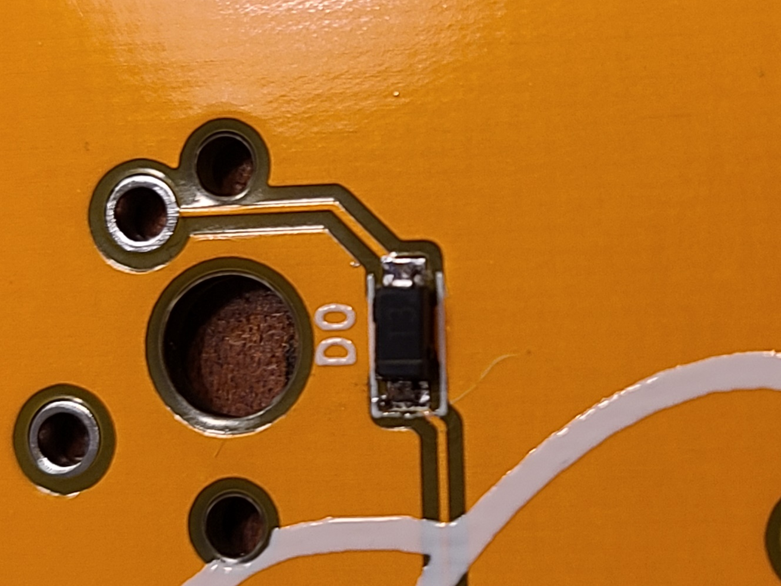

Once you have the diode secured with one leg, you will want to add solder to the loose leg. (PS, the diode that isn’t the same orientation as the others, you want the line pointing upwards.) If you’ve messed up, you can always reheat the solder and move the diode with your tweezers. If you are having a hard time seeing the diodes, good lighting or even your phone flashlight will help a ton.

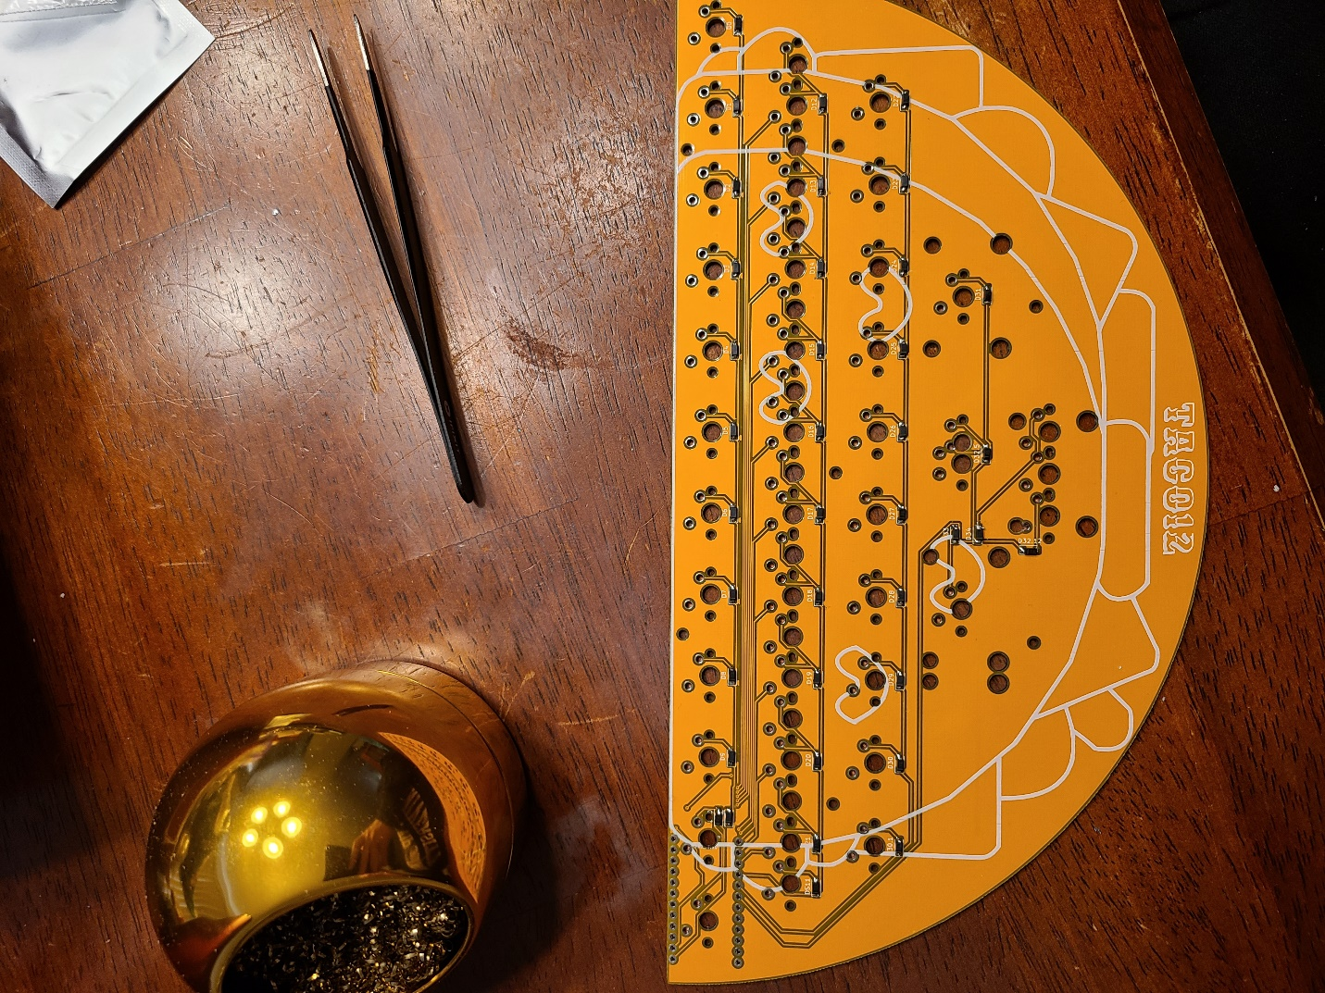

Repeat the above steps for every diode on the board. Once you’re finished go ahead to the next step.

This is a good place to take a break and eat a snack.

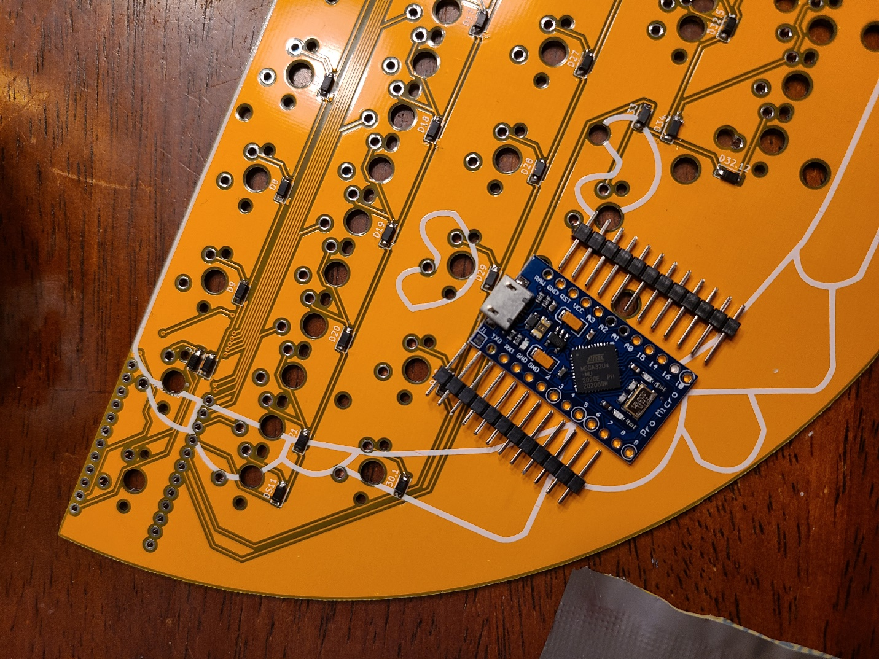

Now you will want to open your pro micro or compatible device.

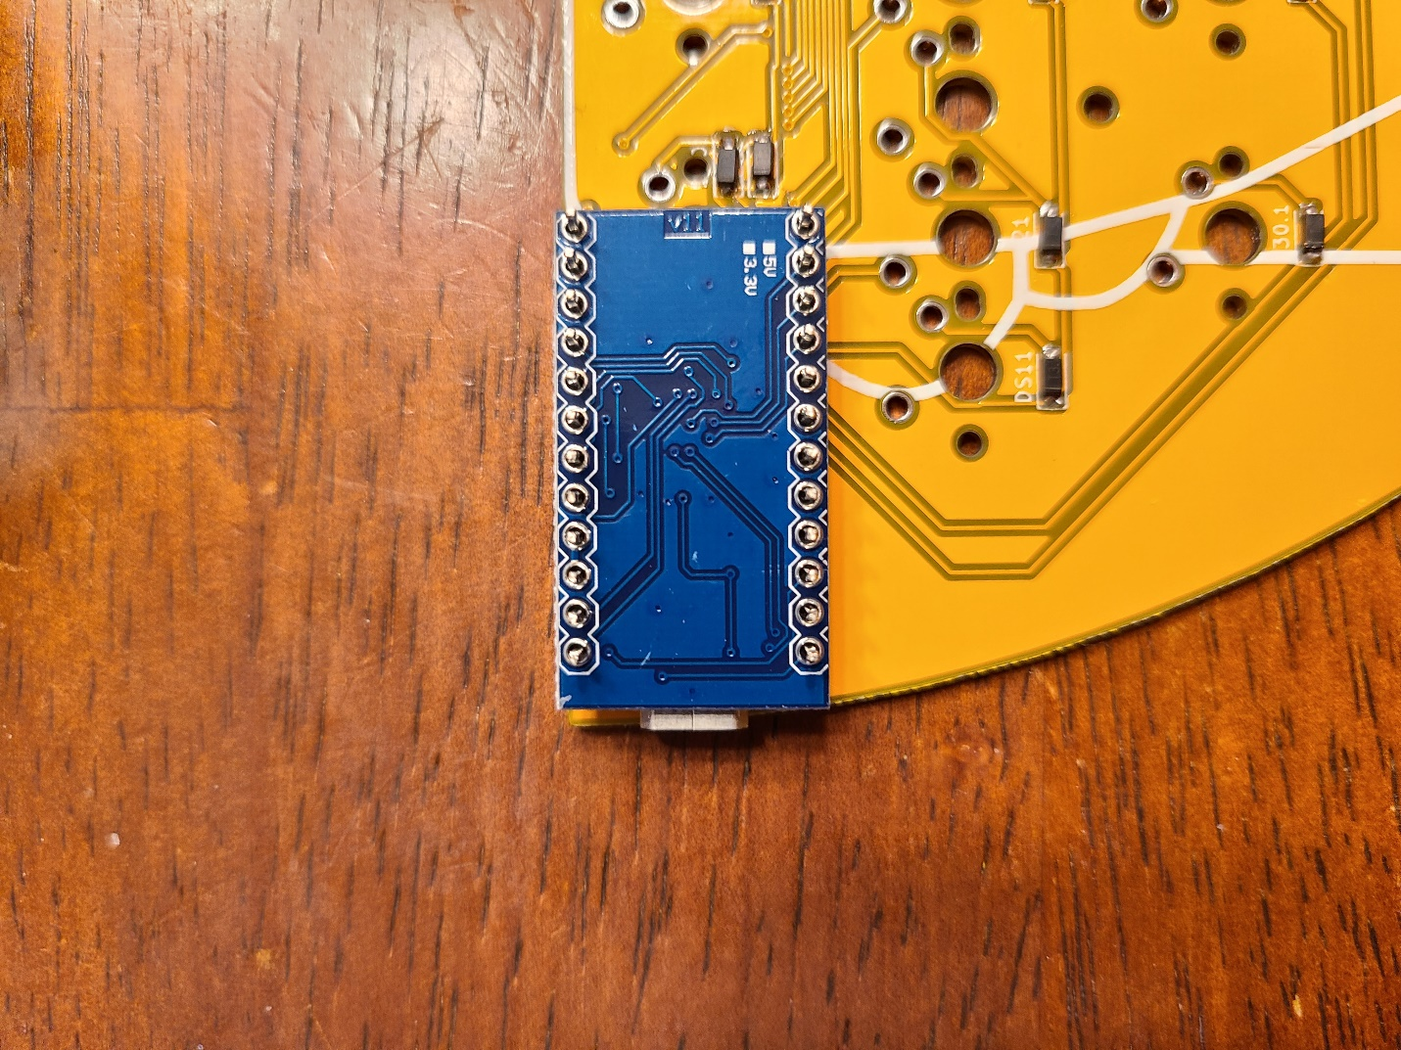

Place the pro micro in the shown orientation. You will place the headers into your Taco12 PCB.

Next place your Pro Micro with the USB port touching the PCB.

**DO NOT** solder the pro micro right now.

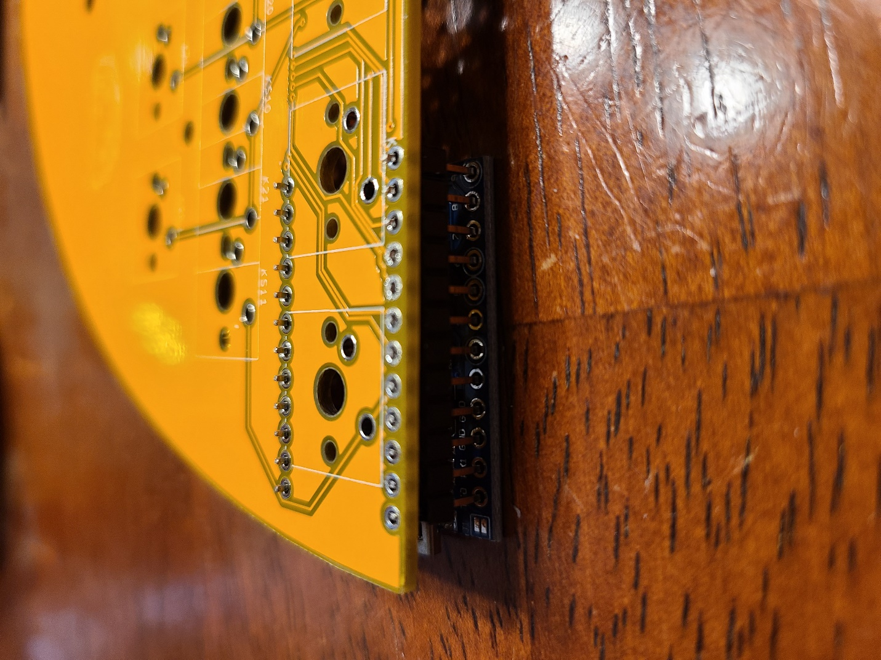

Flip over your Taco12 keeping everything in the same positions

**DO NOT** solder the pro micro right now.

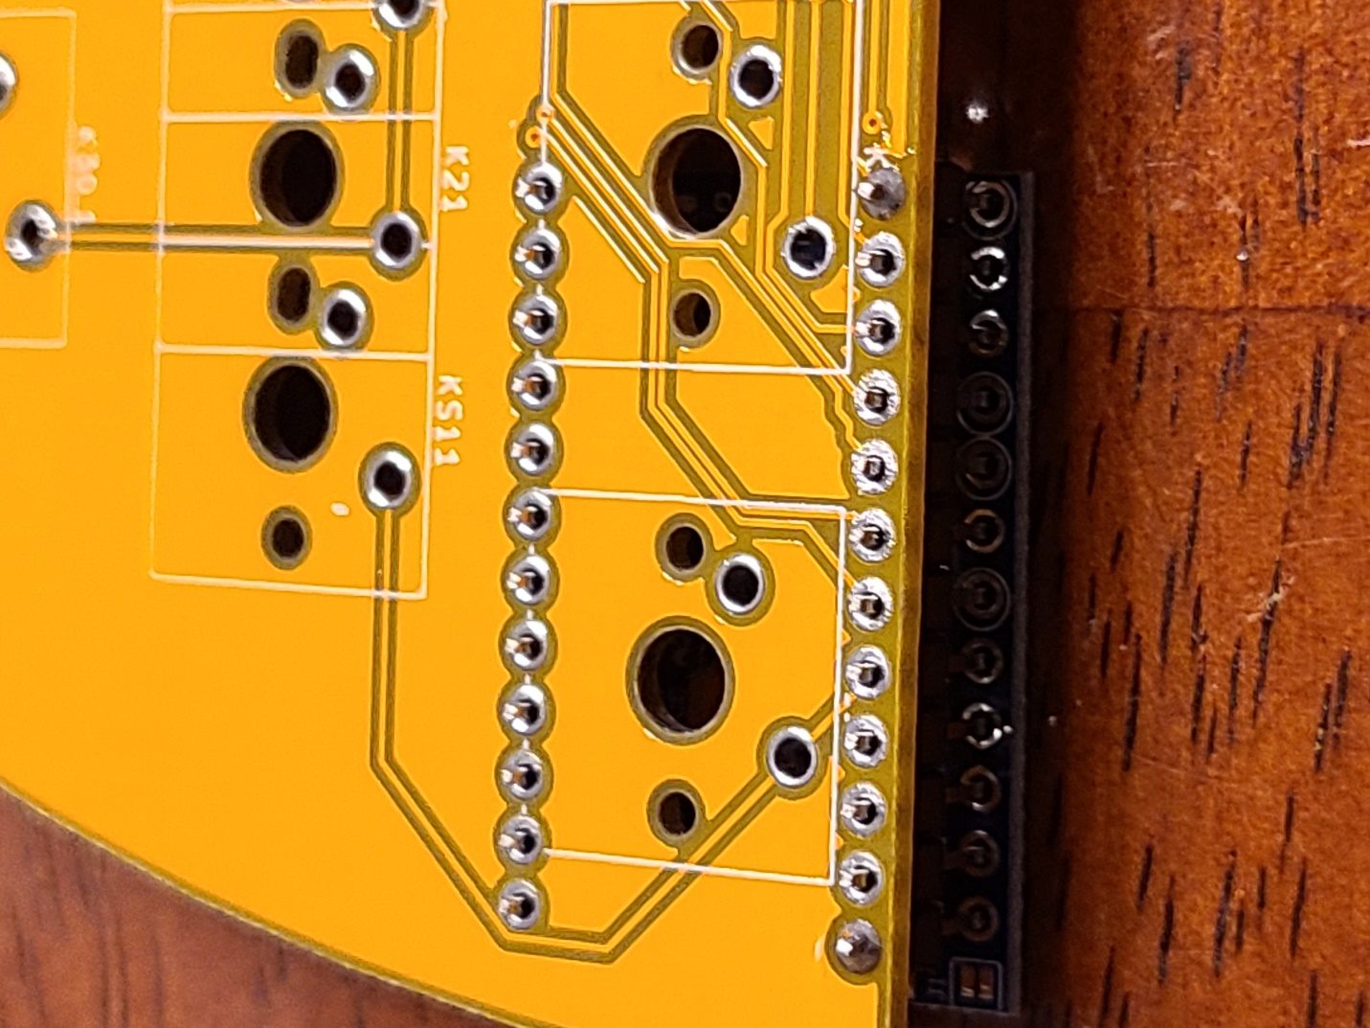

Start by soldering the corners of each set of headers. While doing this, squeeze the pro micro and headers against the PCB, attempt to keep everything straight.

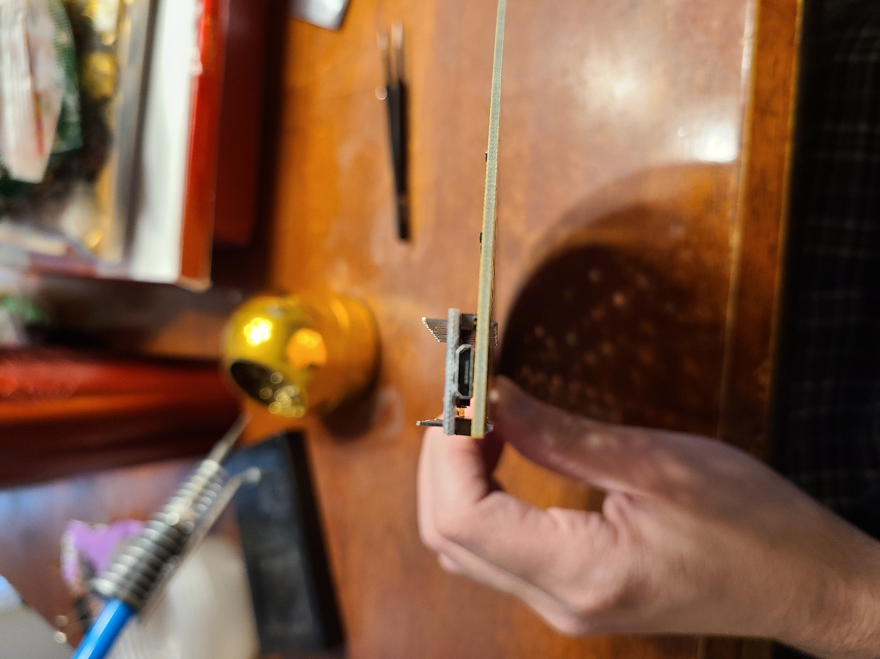

At this point, check to see if your pro micro is sitting straight and as squeezed down as possible. If not, reheat the corner solder joints and move things until you are happy with how it looks.

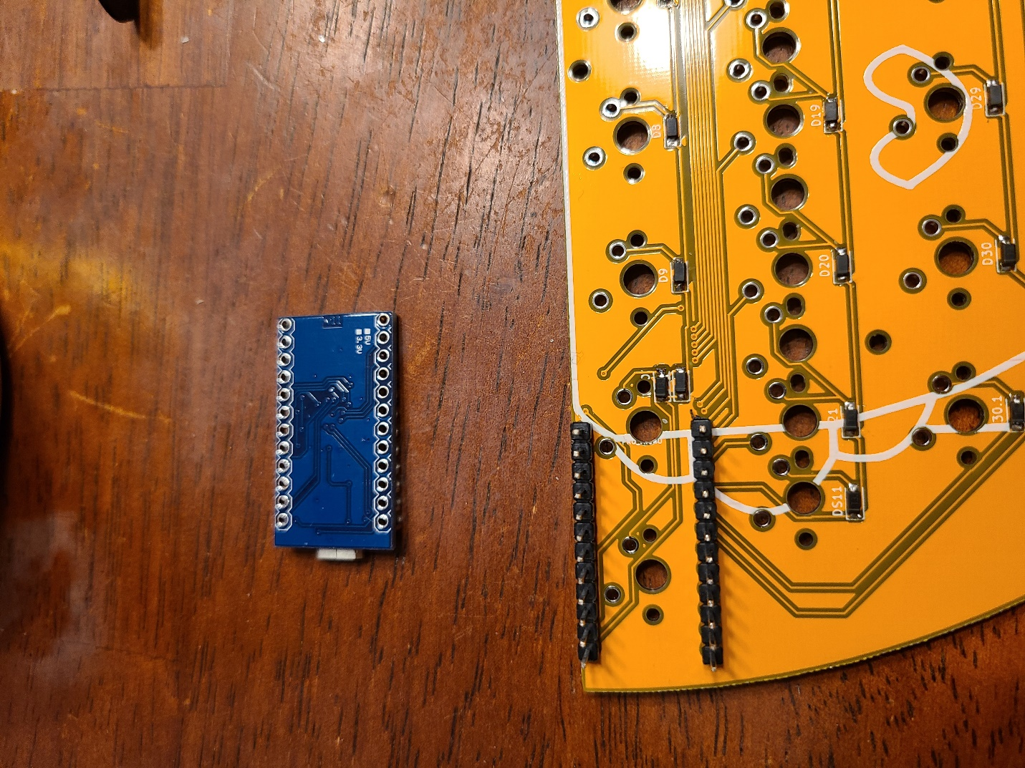

Now you want to take the pro micro off the headers and set it to the side. Go ahead and finish soldering the rest of the contact points to the headers and Taco12 PCB.

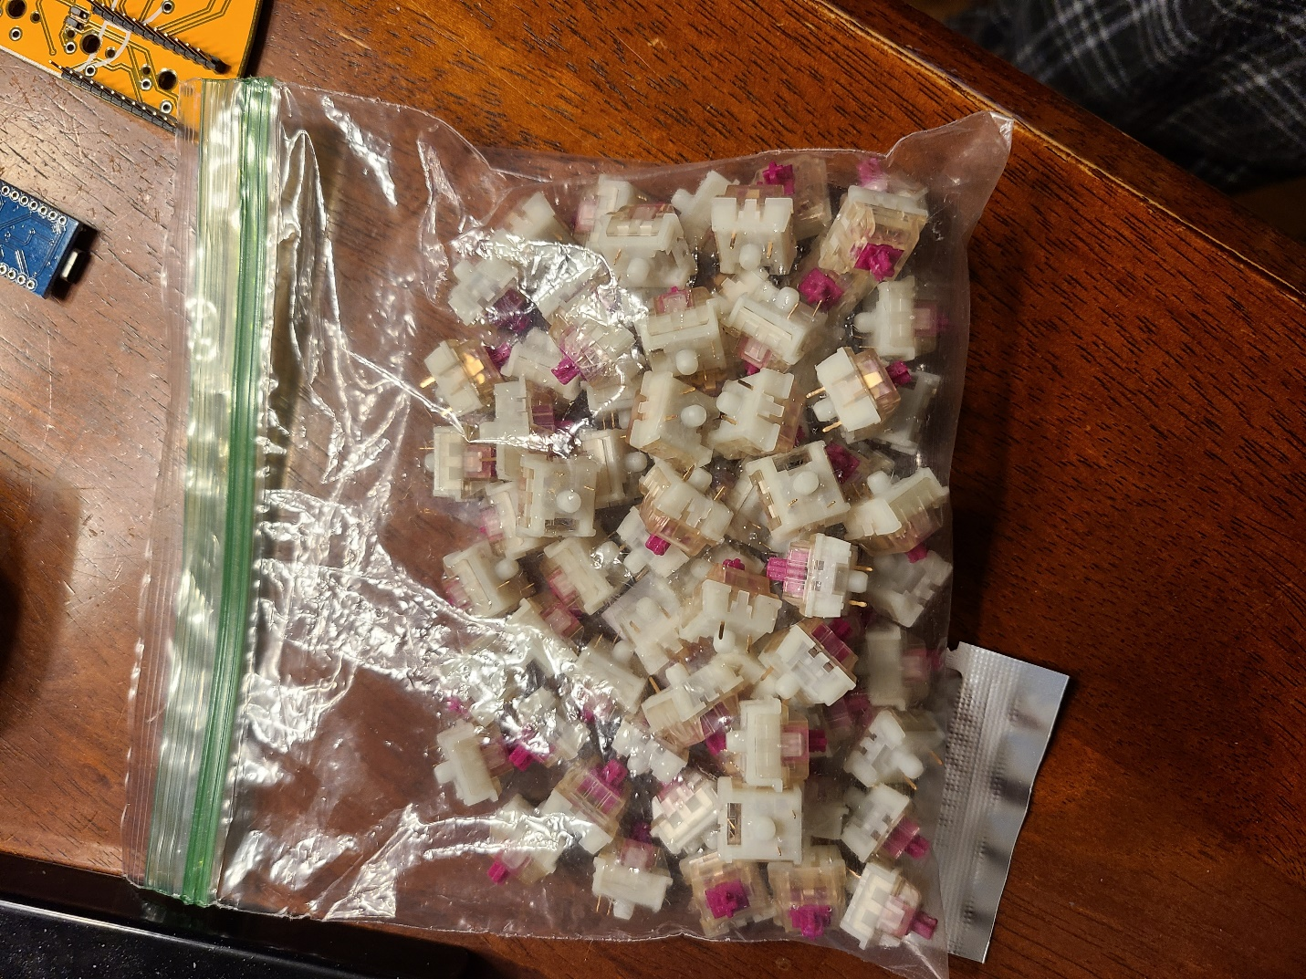

Now it’s time to pick up your switches!

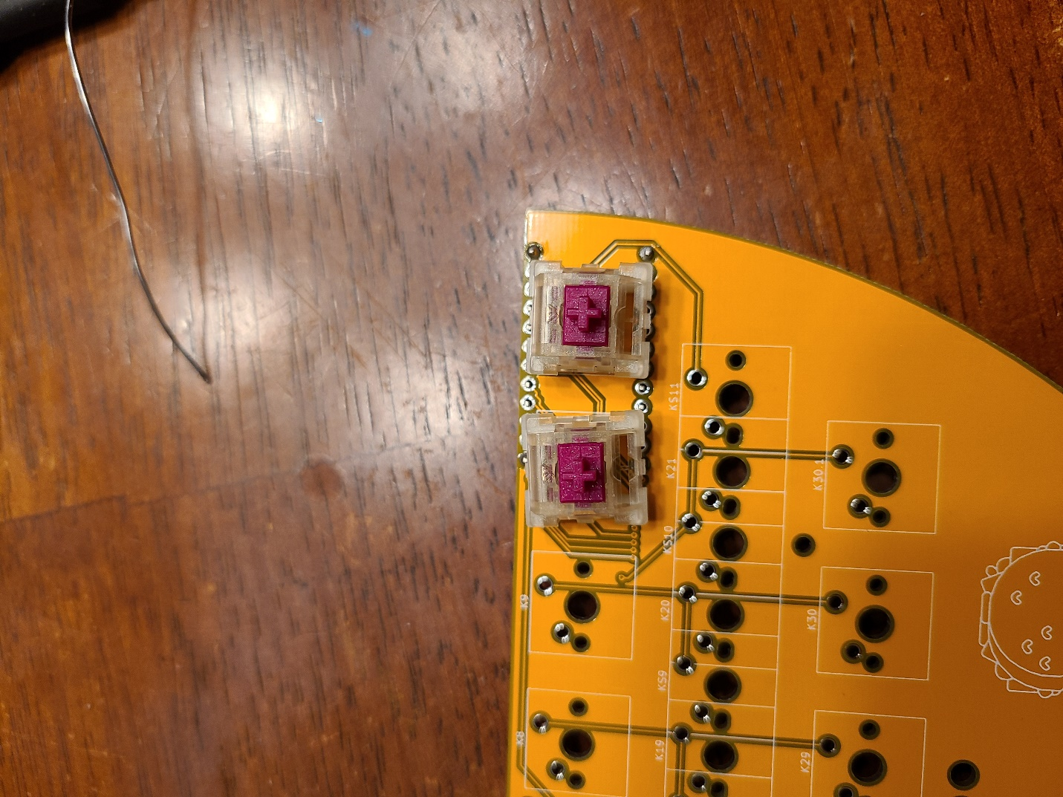

I ***highly*** recommend using 5 pin switches for this build. The extra pins will keep the switch in place because no plate is being used. You will want to solder the switches in the pro micro position first.

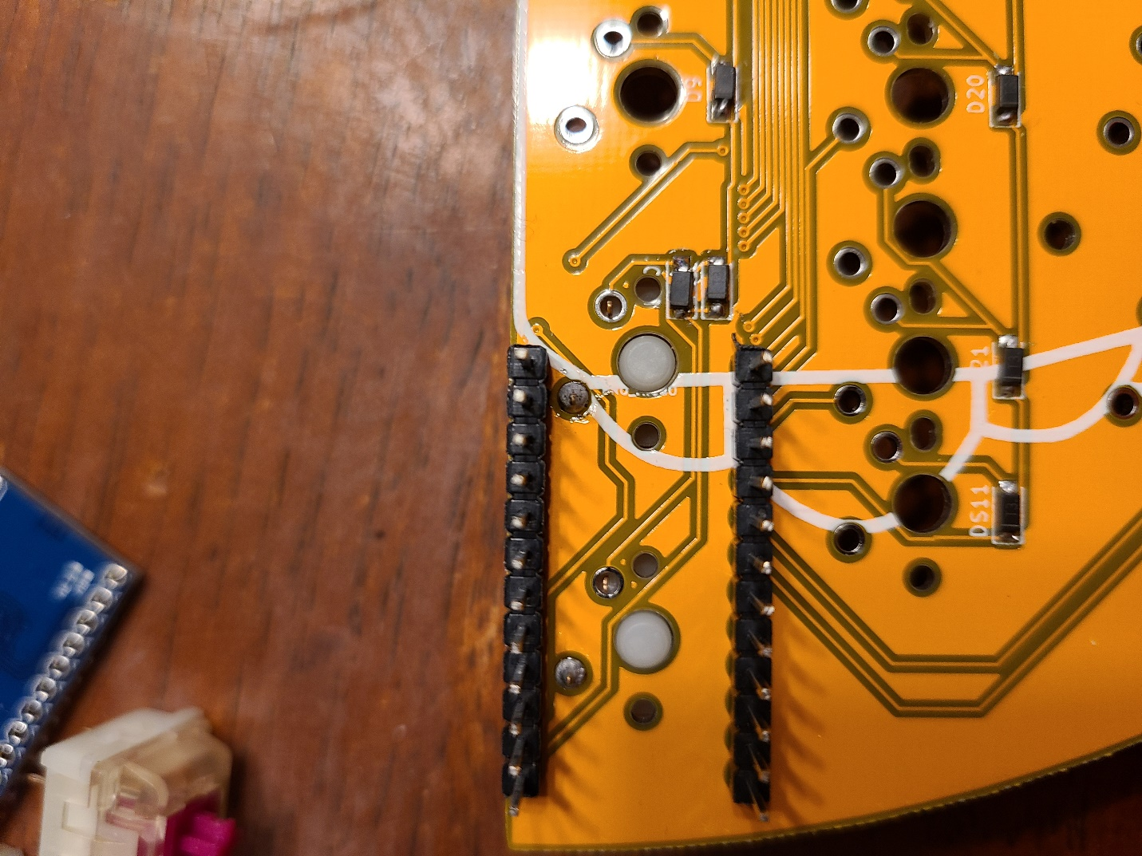

If Using 3 Pin Switches—

The left pin hole(top in this picture) is the larger hole and you shoulder solder it first without soldering the right if you are using 3 pin switches like I am.

If Using 5 Pin Switches—

Place the two switches above and make sure they are pressed flush in the PCB before soldering.

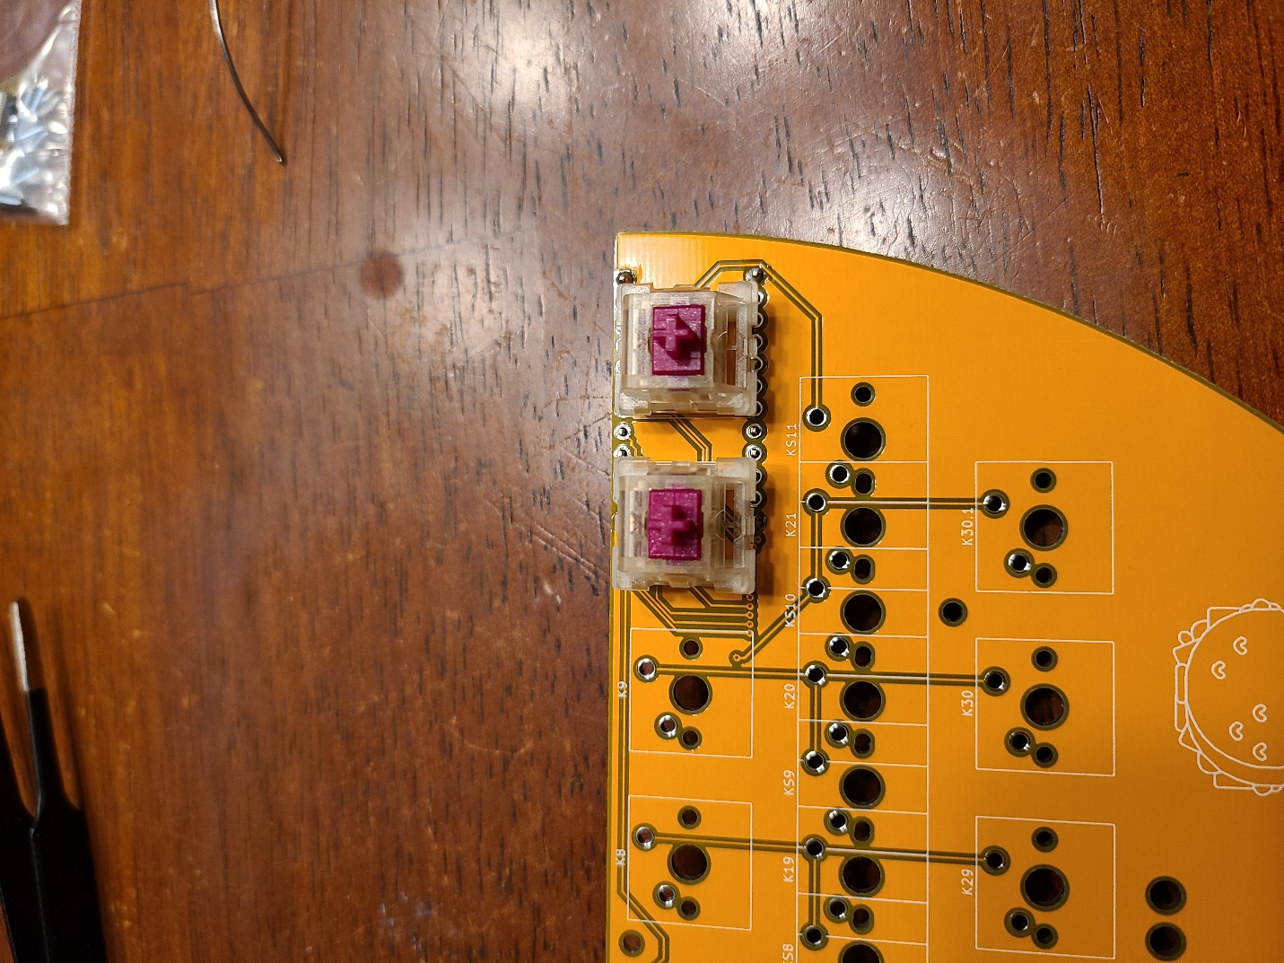

If Using 3 pin switches, you will want to check the other side of the PCB and check the orientation of the switches to make sure they are relatively straight. From this point solder in the rest of your switches.



Make sure you have soldered all your diodes and switches in. TRIPLE check the ones under your Pro Micro, you will NOT be able to easily fix these if there is an issue and you did not socket your pro micro. At this point, place the pro micro back into the shown orientation. Now you can solder the Pro Micro into place.

Now you need to flash your pro micro with the appropriate software. If you have not done this before, follow this guide <https://beta.docs.qmk.fm/tutorial/newbs_flashing>

The easiest way to complete this is will QMK Toolbox.

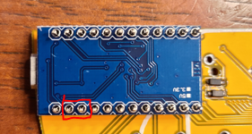

The two pins in the red box are RST and GND, you will need to short these pins with something metal to put the Pro Micro into the bootloader. Again, follow the QMK guide if you haven’t done this before. The precompiled files will be available on my GitHub as well as the files you would need to modify.

I hope to get the Taco12 firmware merged into the main QMK branch soon. If you have any questions please come to the discord and ask away! <https://discord.com/invite/QKPhDEH9gE>

Bottom Case assembly- Place 4 screws into the outermost holes (or others if you so desire) and screw in the standoffs.

Align the Bottom plate with the Taco picture facing away from the back of the PCB, and put the screws into the corresponding 4 holes that have the standoffs.

Finally, put the 4 rubber feet on opposing corners of the bottom plate to keep the screws from scratching your desk as well as keeping it from moving.

From this point, everything should work!